LAB # 01

Lab Task:
- Write a script that take user input for a number then adds 3 to that number. Then multiplies the result by 2, subtract 4, then again adds 3, then print the result.
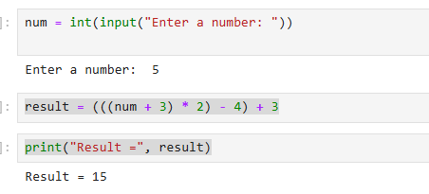

- Write a script that takes input as Celsius and then convert Celsius to Fahrenheit. (hint: Fahrenheit = (Celsius * 1.8) + 32)
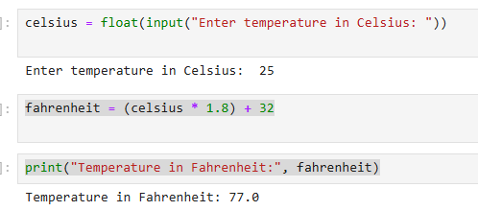

- Write a script that takes input as radius then calculate area of circle. (hint: A = πr²)
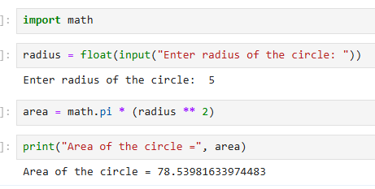

- Write a Python script that asks users for their favorite color. Create the following output (assuming red is the chosen color) (hint: use ‘+’ and ‘*’)

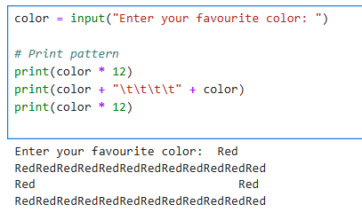

- Store a person’s name, and include some whitespace characters at the beginning and end of the name. Make sure you use each character combination, "\t" and "\n", at least once. Print the name once, so the whitespace around the name is displayed. Then print the name using each of the three stripping functions, lstrip( ), rstrip(), and strip().
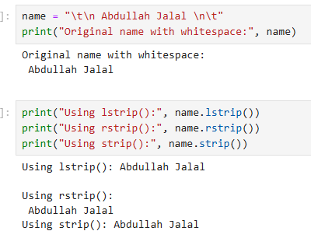
- Write a python script that take a user input and to create the multiplication table (from 1 to 10) of that number.
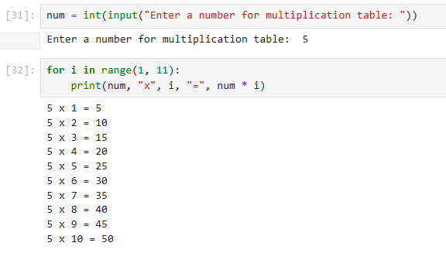
- Write a function called describe_city( ) that accepts the name of a city and its country. The function should print a simple sentence, such as Islamabad is in Pakistan. Give the parameter for the country a default value. Call your function for three different cities, at least one of which is not in the default country.
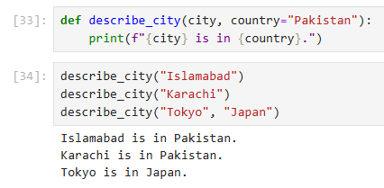

- Write a function called absolute_num() that accepts one parameter, num. The function should return only positive value, and apply condition on it. This function returns the absolute value of the entered number.
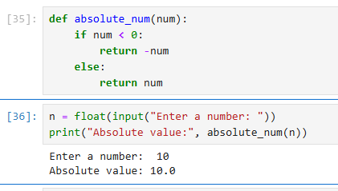

- Write Python Program to check whether an alphabet is a vowel or consonant? (use if, else conditional statement).

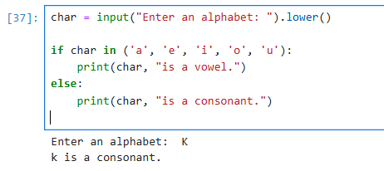

- Write a Python program to check whether a number is prime or not? (use if, else conditional statement).

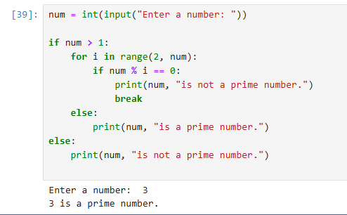

- Write a Python program that prints all the numbers from 0 to 6 except 3 and 6. (Hint: Use 'continue' statement).

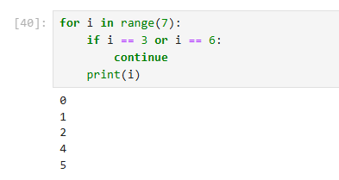

- Write a Python program to construct the following pattern. (using nested loop)

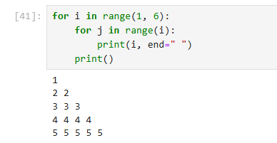
- Stages of Life: Write an if-elif-else chain that determines a person’s stage of life. Set a value for the variable age, and then:

